Press Release

The president of Theatre Accessibility network, Asako Hirokawa, is awarded the 66th Art Encouragement Prize for New Artists

Tokyo (Japan) - March 16, 2016 - The NPO Theatre Accessibility network (TA-net) is pleased to announce that its president, Asako Hirokawa, received the Minister of Education, Culture, Sports, Science and Technology’s Art Encouragement Prize for New Artists (of development of the arts). The Agency of Cultural Affairs, Government of Japan, said she won the prize for the TA-net Symposium “What we can do now for building up the more accessible theatrical system,” which was held last year. The Agency also announced her winning reason as follows:

Most theatres in Japan do not provide the support for the patrons with audio-visual disabilities which would facilitate them the access to performing arts. Ms. Asako Hirokawa, who is Deaf herself, founded the non-profit organization “Theatre Accessibility network” with the aim of changing this situation, and started its various activities to improve the theatrical environment of the disabled people, under the watchword “Let's Enjoy Performing Arts Together” The TA-net is branching out constantly year after year. It is expected that she and the TA-net will vigorously continue expanding their activities with their conscientious productive efforts.

The TA-net appreciates all of your past and future support. We hope this prize will be a help to increase the social recognition of the performing arts accessibility.

The awarding ceremony was held on Tuesday, March 15, 2016.

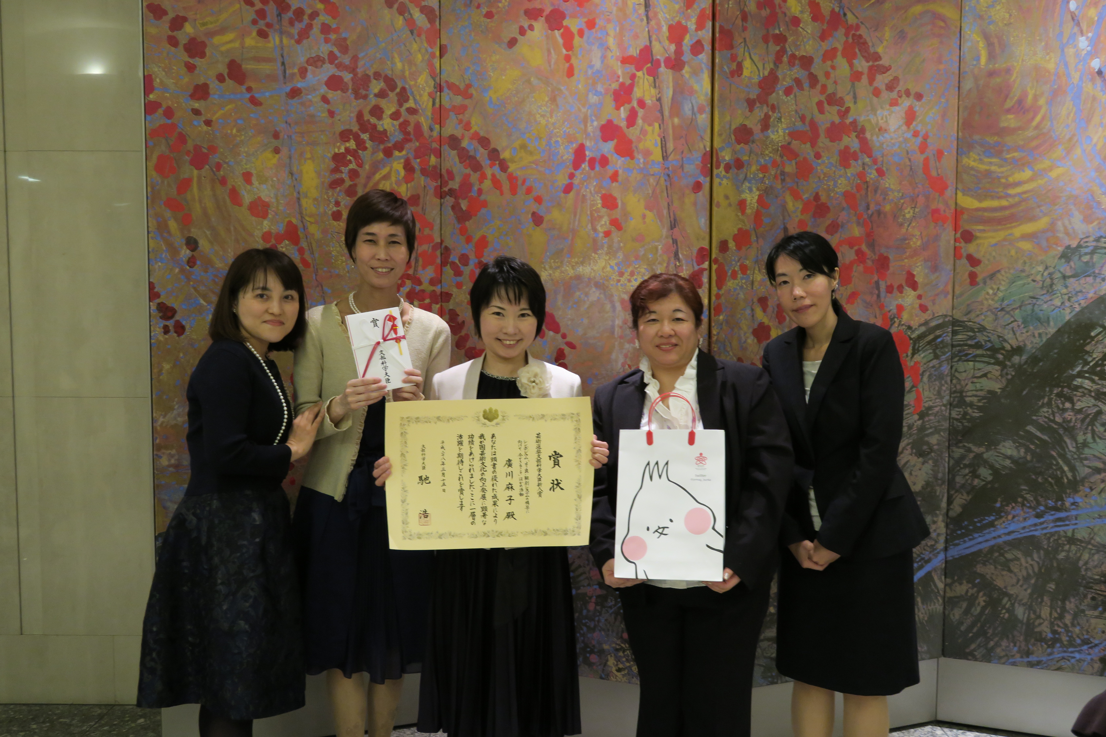
[Contact]
NPO Theatre Accessibility network
Daita 4-13-8, Setagaya-ku, Tokyo, 155-0033 Japan
FAX: 020-4664-1221 (from Japan only)
Email: tacc.net@gmail.com
URL: http://ta-net.org/

